PASSING AN ARRAY ELEMENT IN A FUNCTION
#include <stdio.h>
void display(int age)
{
printf("Age is %d", age);
}

int main()
{
int ageArray[] = { 2, 3, 4 };
display(ageArray[2]); //Passing array element ageArray[2] only.
return 0;
}

PASSING AN ENTIRE ARRAY IN A FUNCTION
C program to pass an entire array containing age of 5 persons to a function. This function should find average age and display the average age in main function.
#include <stdio.h>
float average(float age[]);
int main()​
{
float avg, age[] = { 23.4, 55, 22.6, 3, 40.5, 18 };
avg = average(age); /* Only name of array is passed as argument. */
printf("Average age=%f", avg);
return 0;
}
float average(float age[])
{
int i;
float avg, sum = 0.0;
for (i = 0; i < 6; ++i) {
sum += age[i];
}
avg = (sum / 6);
return avg;
}

C Program to find the largest element in an array by passing entire array to a function .
#include<stdio.h>
int find_largest(int arr[],int);
int main()
{
int arr[30],size,largest,i;
printf("Enter the size of the array maximum up to 30: ");
scanf("%d",&size);
printf("Enter the %d integer numbers: ",size);
for(i=0;i<size;i++)
scanf("%d",&arr[i]);
largest = find_largest(arr,size);
printf("\nThe largest element is: %d\n",largest);
return 0;

}
int find_largest(int arr1[],int size1)
{
int temp_larg,i;
temp_larg=arr1[0];
for(i=1;i<size1;i++)
{
if(arr1[i]>temp_larg)
temp_larg=arr1[i];
}
return(temp_larg);
}
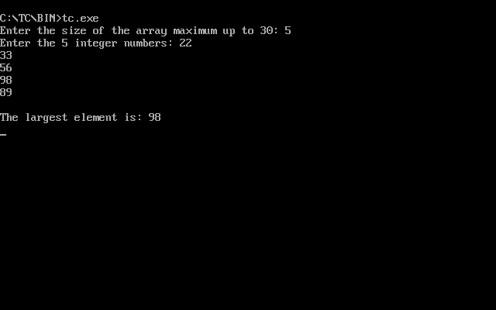
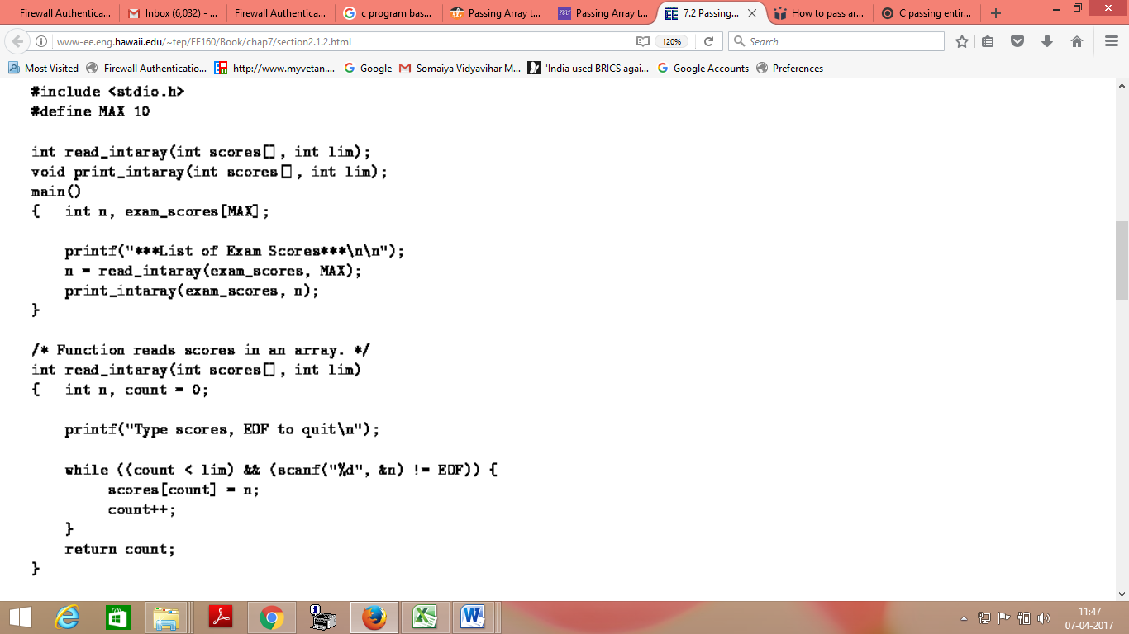

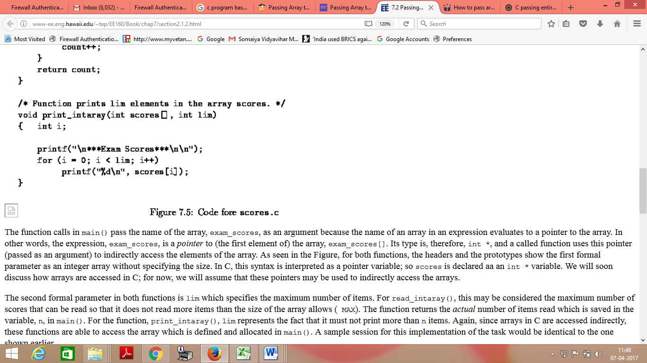

Passing entire array to function :
- Parameter Passing Scheme : Pass by Reference
- Pass name of array as function parameter .
- Name contains the base address i.e ( Address of 0th element )
- Array values are updated in function .
- Values are reflected inside main function also.

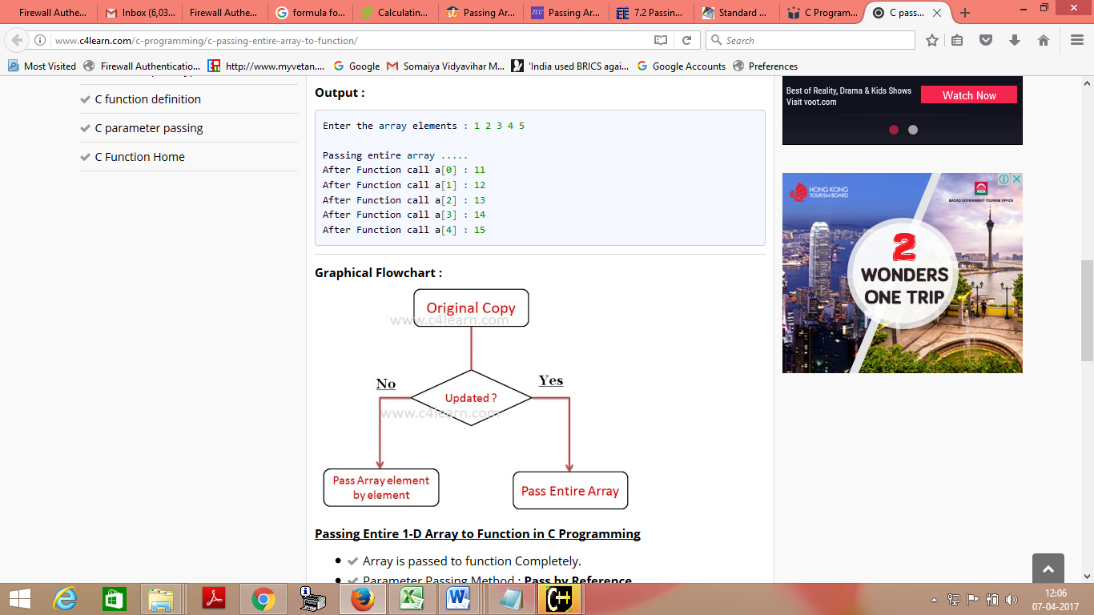

#include<stdio.h>
#include<conio.h>
//---------------------------------
void fun(int arr[])
{
int i;
for(i=0;i< 5;i++)
arr[i] = arr[i] + 10;
}
//--------------------------------
void main()
{
int arr[5],i;
clrscr();
printf("\nEnter the array elements : ");
for(i=0;i< 5;i++)
scanf("%d",&arr[i]);

printf("\nPassing entire array .....");
fun(arr); // Pass only name of array

for(i=0;i< 5;i++)
printf("\nAfter Function call a[%d] : %d",i,arr[i]);

getch();
}

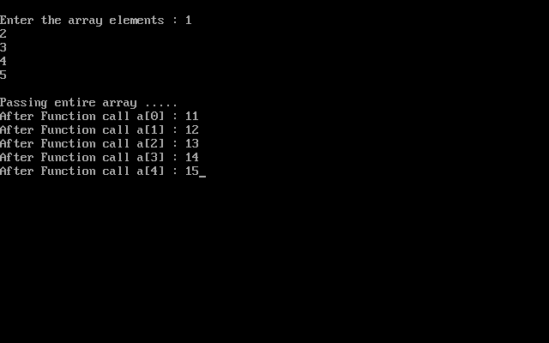

Standard Deviation
The Standard Deviation is a measure of how spread out numbers are.
The symbol for Standard Deviation is σ (the Greek letter sigma).
This is the formula for Standard Deviation:
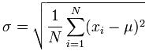

The Formula Explained
First, let us have some example values to work on:


Example: Sam has 20 Rose Bushes.
The number of flowers on each bush is
9, 2, 5, 4, 12, 7, 8, 11, 9, 3, 7, 4, 12, 5, 4, 10, 9, 6, 9, 4
Work out the Standard Deviation.

Step 1. Work out the mean
In the formula above μ (the greek letter "mu") is the mean of all our values ...

Example: 9, 2, 5, 4, 12, 7, 8, 11, 9, 3, 7, 4, 12, 5, 4, 10, 9, 6, 9, 4
The mean is:
9+2+5+4+12+7+8+11+9+3+7+4+12+5+4+10+9+6+9+4/20
= 140 /20 = 7
So:
μ = 7

Step 2. Then for each number: subtract the Mean and square the result
This is the part of the formula that says:
So what is x_{i} ? They are the individual x values 9, 2, 5, 4, 12, 7, etc...
In other words x₁ = 9, x₂ = 2, x₃ = 5, etc.
So it says "for each value, subtract the mean and square the result", like this

Example (continued):
(9 - 7)² = (2)² = 4
(2 - 7)² = (-5)² = 25
(5 - 7)² = (-2)² = 4
(4 - 7)² = (-3)² = 9
(12 - 7)² = (5)² = 25
(7 - 7)² = (0)² = 0
(8 - 7)² = (1)² = 1
... etc ...
And we get these results:
4, 25, 4, 9, 25, 0, 1, 16, 4, 16, 0, 9, 25, 4, 9, 9, 4, 1, 4, 9

Step 3. Then work out the mean of those squared differences.
To work out the mean, add up all the values then divide by how many.
First add up all the values from the previous step.
But how do we say "add them all up" in mathematics? We use "Sigma": Σ
Sigma Notation
We want to add up all the values from 1 to N, where N=20 in our case because there are 20 values:

Example (continued):
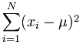
Which means: Sum all values from (x₁-7)² to (x_{N}-7)²

We already calculated (x₁-7)²=4 etc. in the previous step, so just sum them up:
= 4+25+4+9+25+0+1+16+4+16+0+9+25+4+9+9+4+1+4+9 = 178
But that isn't the mean yet, we need to divide by how many, which is simply done by multiplying by "1/N":

Example (continued):
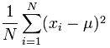
Mean of squared differences = (1/20) × 178 = 8.9
(Note: this value is called the "Variance")

Step 4. Take the square root of that:

Example (concluded):

σ = √(8.9) = 2.983...
DONE!

C Program to Calculate Standard Deviation
This program calculates the standard deviation of 10 data using arrays.
#include <stdio.h>
#include <math.h>

float calculateSD(float data[]);

int main()
{
int i;
float data[10];

printf("Enter 10 elements: ");
for(i=0; i < 10; ++i)
scanf("%f", &data[i]);

printf("\nStandard Deviation = %.6f", calculateSD(data));

return 0;
}

float calculateSD(float data[])
{
float sum = 0.0, mean, standardDeviation = 0.0;

int i;

for(i=0; i<10; ++i)
{
sum += data[i];
}

mean = sum/10;

for(i=0; i<10; ++i)
standardDeviation += pow(data[i] - mean, 2);

return sqrt(standardDeviation/10);
}

Output

Enter 10 elements: 1
2
3
4
5
6
7
8
9
10

Standard Deviation = 2.872281

